Design Phase of the Joint Project around the Senegal Mauritanian Aquifer Basin led by the Regional Working Group

Deliverable number 6:

Review of Water Management Legal and Institutional Frameworks in SMAB Countries, at the National and Regional Levels

DOCUMENT STATUS: APPROVED BY THE REGIONAL WORKING GROUP

  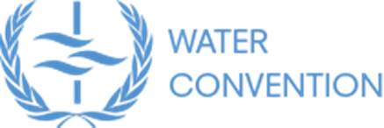 | 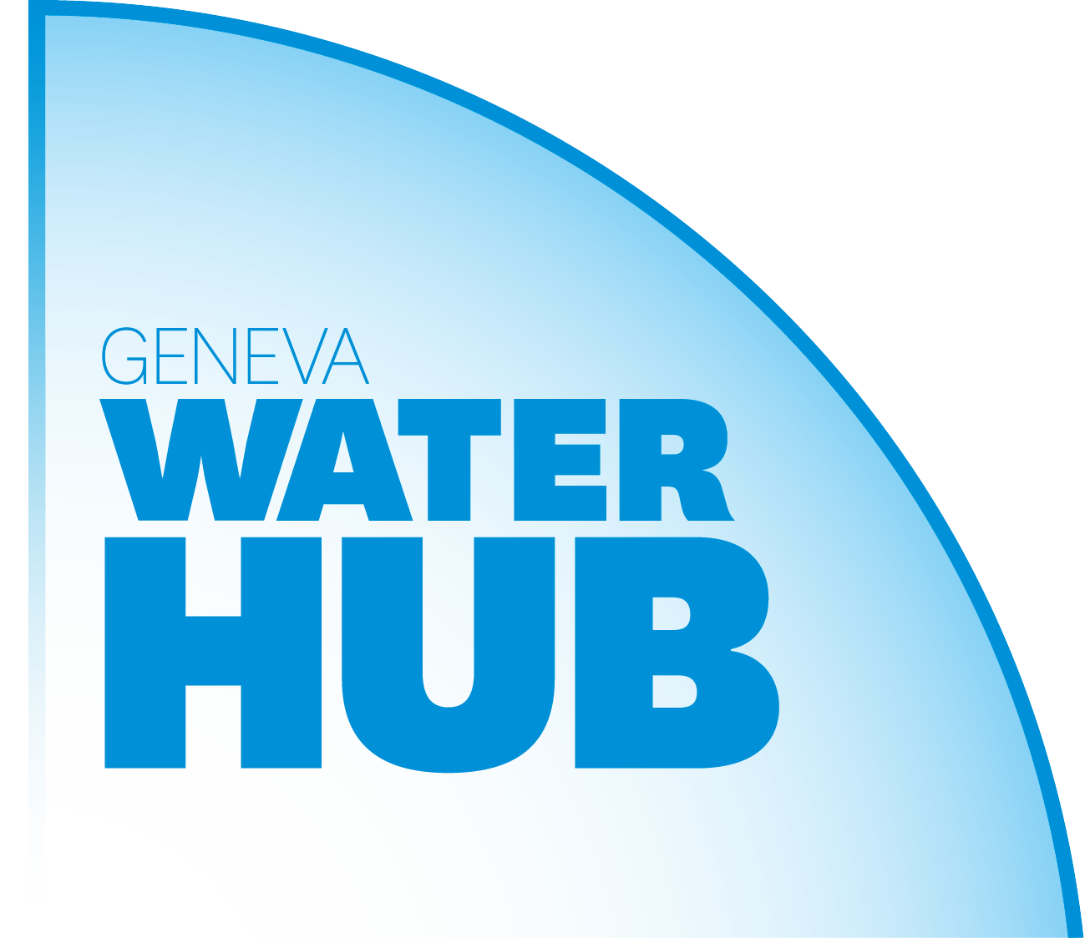 | 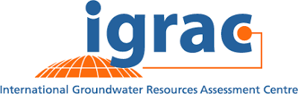
With the financial support of
 |  | 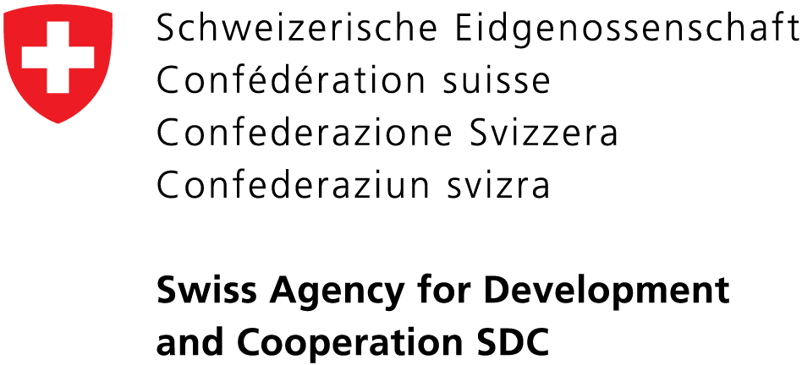

Table of Contents
1 Introduction 3
2 National Frameworks 3
2.1 Legal frameworks 3
Table 1: List of national texts studied 4
Table 2: Legal provisions regarding water 5
2.2 Institutional frameworks 13
Table 3: Institutions involved in water management 15
3 The transboundary regional framework 22
Table 4: List of international legal instruments analysed 22
3.1 The regional institutional framework 23
Table 5: Structure and operations of TBOs (OMVS and OMVG) 25
3.2 Principles of water management 27
Table 6: Senegal and Gambia River Water Charters 28
Table 7: Summary of international instruments and comparison with Water Charters and national legislations 33
4 Conclusion 37

Introduction
This report presents an overview of the legal and institutional framework for water management in the four SMAB countries: Gambia, Guinea Bissau, Mauritania and Senegal, with a special focus on groundwater. The report will present national and regional frameworks established through transboundary basin organizations (TBOs), that is, the Gambia River Basin Development Organization (OMVG) and the Senegal River Basin Development Organization (OMVS).
With transboundary water resources, it is equally important to examine the national framework of each riparian State, in addition to any existing regional frameworks. Water resources are managed both nationally and locally, and transboundary water is managed by each State according to its own national legislation and regulations, through its own institutions. It is important to understand and analyse these frameworks, in order to verify their compatibility with the system in place at the transboundary level as part of this cooperation (decisions adopted at the transboundary level should then be implemented by each country at the national level). This analysis is also critical for comparing national systems and ensuring the harmonization of national policies with regard to decisions to be adopted at the transboundary level.

National Frameworks

Legal frameworks
The legal situation with regard to water in general was studied in all four countries, and groundwater in particular was examined based on national laws on water, and, when applicable, related legislation, such as that on the environment.
The analysis was focused along the following lines, which are indispensable to sustainable water resources management:
- The legal status of water, or its ownership (public ownership allows the State to regulate water).
- Quantitative protection, or monitoring extraction and use, which makes it possible to control water volume and ensure its availability for all users).
- Qualitative protection, which includes measures regarding waste and effluent, as well as the requirement of an impact study, or buffer zones.
- In the case of groundwater, an impact study for any planned activities, in order to identify what damage, whether due to pollution or other causes, might reach the aquifer. Buffer zones around a catchment exist to maintain water quality, and they are particularly planned for vulnerable zones.
Both protective measures take on their full dimension in the case of aquifers, where the resource is invisible and can be affected and polluted by activities unrelated to water use, due to potential ground infiltration, waste storage or industrial or commercial discharge.
- The order of priorities among uses. Identifying the order of priorities takes on new meaning with the international recognition of the right to access to water, and in cases of events such as drought or flooding, which may disrupt water use and alter distribution.
- Financial provisions.

A list of instruments studied is provided in the table below.
A water code is available in three countries: Guinea Bissau, Mauritania and Senegal.
In Gambia, a water sector reform project was initiated in 2011-2015. This involved the preparation of a water draft bill, as well as the creation of the National Water Resources Management Authority (draft bill). However, the reform has not yet been implemented. Therefore, water is hardly-regulated in Gambia, besides some provisions in the national environment management act 1994. According to experts interviewed when preparing these deliverables, the water sector in Gambia currently finds itself in a situation of uncertainty and legal void.
In Guinea Bissau, the Water Code dates back to 1992. Experts interviewed indicated that this code needs to be revised. Several attempts have been made to update it, albeit unsuccessfully. In Mauritania, the 2005 Water Code is currently being revised. The situation in Senegal is the same as in Mauritania- the 1981 Water Code is being revised, and the new text appears to be ready for adoption.
The analysis focused on documents currently enforced, with the exception of Gambia, where draft bills are available not enacted.

Table 1: List of national texts studied
(draft laws in blue)
 | Gambia | Guinea Bissau | Mauritania | Senegal
Legal texts on water management | The Gambia Water Bill (2014) (draft bill on water)  National Environment Management Act (1994) | Water Code (1992) | Water Code (2005) | Water Code (1981)  Environmental Code (2001)
Legal texts on institutional organization | National Water Resources Council Act (1979)  National Water Resources Management Authority Bill (2014) | Decree on the organization of the Ministry of Natural Resources  (1992) | Decree establishing the powers of the Ministry of Water and Sanitation and the organization of its Department’s Central Administration (2020)  Decree on the creation and organization of an establishment known as the “National Water Resources Centre”  C.N.R.E | Decree on the organization of the Ministry of Water and Sanitation  (2018)  Decree number 2014-880 of 22 July 2014 on the powers of the Ministry of the Environment and Sustainable Development

Table 2 below includes the main provisions of national laws reflecting the requirements listed above.

Table 2: Legal provisions regarding water
(draft texts in blue)
 | Gambia | Guinea Bissau | Mauritania | Senegal
Water ownership | Granted to the State. (Article 5 of the Water Bill)  Affects all waterways, surface water, water sources and groundwater. | Public domain (Article 2 of the Water Code):  All water resources (atmospheric, surface and groundwater), all water sources. | Property of the Nation (Article 2 of the Water Code)  Public domain of the State  Superficial, groundwater and atmospheric water resources. (Article 6)  Riverbeds and aquifers. (Article 7) | Public domain. (Article 2 of the Water Code)
Monitoring extraction and use | Authorization is necessary for water prospecting, digging a well and extracting water. (Article 8 of the Water Bill) | Any water extraction or use must be authorized. The code sets out four types of water use. (Article 6 of the Water Code)  In the case of artificial accumulation, free use is allowed. (Article 7 of the Water Code)  Groundwater extraction using mechanical means must be reported. (Article 8 of the Water Code)  Groundwater research, extraction and use are subject to authorization. (Article 9 of the Water Code)  Concessions apply to facilities or activities in the general interest and public use. (Article 10 of the Water Code)  . | Extracting water for domestic use (defined by Decree) is exempted from any formalities.  Operations, facilities, capture and extraction for non-domestic use are subject to reporting, authorization or concession (conditions set by Decree). (Article 18 of the Water Code)  Reporting: operations presenting minor dangers to public health and safety, and limited impact on water flow (quantitative and qualitative) and aquatic environmental diversity (Article 19 of the Water Code)  Authorization: operations likely to present a danger to public health and safety, to harm water flow, reduce water resources and harm water quality and aquatic environmental diversity. (Article 20 of the Water Code)  Concession: Operations likely to present serious danger to public health and safety, to significantly harm water flows, to reduce water resources and seriously affect the quality and diversity of the aquatic environment.  Operations in the general interest or having benefitted from a declaration of public utility. (Article 21 of the Water Code)  In the case of drought, accidental pollution or flooding, the Ministry of Water may limit or suspend water use. In cases of quantitative or qualitative threats to water resources, strategic safeguard zones may be established. (Article 32 of the Water Code)  Procedures are set forth by decree. (Article 33 of the Water Code) | - Authorization system:  Any groundwater catchwork project involving wells, boreholes or infiltration galleries must flow at a rate of at least 5 cubic meters per hour, equip an existing catchwork project or draw from a water source classified as Zone I.  (Article 9 of the Water Code)  When authorization is granted, the beneficiary shall indicate the rate of extraction from the water source. (Article 13 of the Water Code)  In Zone I: Any catch work requires authorization (Article 33 of the Water Code); authorization shall set limits on annual, daily and hourly extraction volumes (Article 34 of the Water Code); no new authorization requests will be accepted if the water source is reported to have reached its extraction limits (by decree based on reports from the Ministry of Water and Sanitation)  When groundwater is located along a lake or river, its capture may be subject to surface water rules (a decree based on a report from the Ministry of Water and Sanitation sets the rules subjecting these waters to surface water regulations). (Article 37 of the Water Code)
Usage order of priority | Satisfying essential human needs is the priority. (Article 9 of the Water Bill) |  | Priority is given to supplying drinking water. Based on local demand, other priorities are listed below:  Livestock  Agriculture  Forestry  Fish farming  Continental fishing  Reforestation  Industry and mining  (Article 5 of the Water Code) | Priority is given to supplying drinking water.  This is followed by livestock, agriculture, forestry, fish farming and reforestation projects, followed by the needs of industrial and agro-industrial complexes.  River navigation, hydroelectric energy production, mining companies and the tourism industry are satisfied based on their economic priority. (Articles 75 and 76 of the Water Code)
Water quality protection | The National Environment Agency establishes water quality criteria and measures. The Agency sets water quality standards, considering various uses (drinking water, industrial, agriculture, fishing, nature and leisure). (Articles 28§1b and §2b of the National Environmental Management Act 1994)  Discharging dangerous substances into water is prohibited, except when permitted by regulations of the National Environmental Management Council. (Article 38§1 of the National Environmental Management Law)  Authorization is required before discharging sewage or other substances (Article 8 of the Water Bill)  The responsible Ministry will ensure coordination, development, monitoring and implementation of all water standards, including drinking water quality, and standards on discharged effluents. The Ministry ensures the protection of recharge zones. Sea-water intrusion in aquifers as well as in the freshwater-saltwater interface of the Gambia River will be monitored. (Article 10 of the Water Bill) | Polluting superficial or groundwater with waste is prohibited.  The Ministries of Water and Health issue a joint decision on quantitative and qualitative limits, on the basis of which waste is subject to authorization. (Article 33 of the Water Code)  These two Ministries establish the drinking water parameters and monitoring methods. (Article 34 of the Water Code) | In the case of drought, accidental pollution or flooding, the Ministry of Water can limit or suspend water use.  In the case of a quantitative or qualitative threat to water resources, strategic safeguard zones may be established. (Article 32 of the Water Code)  Methods are established by decree (Article 33 of the Water Code)  Any discharge into groundwater or surface water of one or more substances that may have a harmful effect on health and the environment is punishable with imprisonment and/or a fine. (Article 71 of the Water Code) | Authorization is required for any overflow, effluent, waste or direct or indirect alluvial into a groundwater source that is likely to modify physical features, including thermal and radio-atomic, chemical, biological or bacteriological features.  (Article 49 of the Water Code)  Using individual wells for human water supply is only authorized when all precautions have been taken to protect these wells from contamination due to proximity to latrines, septic tanks, manure stores, waste, garbage and cemeteries. Water in these wells must always comply with qualities required by regulation and standards set by the Ministry of Health. (Article 55 of the Water Code)  Measures aimed at preventing water pollution are determined via joint decree by the Ministries of Water and Sanitation and Public Health and the Environment. (Article 50 of the Water Code)  Any discharge, spill, store, jet, landfill and direct or indirect immersion of domestic or industrial liquid waste into natural environments shall be subject to decontamination pursuant to legal texts in force. (Article L3 of the Environmental Code)  The discharge of unfiltered domestic effluents, excrement and sludge into gutters, open-air rainwater drains or closed storm water pipes, or onto the surface of natural or developed soil is prohibited throughout national territory. (Article L13 of the Environmental Code)  No authorization is granted for the discharge of domestic sewage via infiltration, percolation or absorption if the effluents emerge less than 35 metres from a well or spring, or less than 15 metres from a surface water reserve or watercourse where the low flow rate is less than five cubic metres/second. (Article L13 of the Environmental Code)  Any classified facility must include a file describing its activities, the purification system it plans to use and a commitment to follow decontamination standards set by various codes and their implementing legislation in any application for building authorization. (Article L3 of the Environmental Code)  Sludge from septic tanks may not be discharged, except in strict and well-defined conditions. (Article L79 of the Environmental Code)  The Ministry of the Environment, in concert with other relevant ministries shall establish the list of substances that may not be discharged, or which are subject to authorization via decree, along with the physical criteria with which they must comply and other conditions. (Articles L61 and L62 of the Environmental Code)
Environmental impact study | In the case of projects in a category listed in annexes to the law, the National Environmental Agency may, following a case study, decide to send the project for an impact study. (Article 22§3 of the National Environmental Management Law) | An impact study is required prior to approval of projects that may impact water quality. (Article 33 of the Water Code) |  | An impact study is required for any development project or activity likely to cause environmental harm. (Chapter V of the Environmental Code)  Details: Implementing decree of the Environmental Code. (Title II) (12 April 2001)
Buffer zone |  | A buffer zone is established around any catchwork for drinking water supply for cities or settlements. The limits are set on a case-by-case basis by the Ministry of Water. Additionally, the following activities are prohibited within the buffer zone:  - - Building residences or any other buildings  - - Building industrial or commercial establishments  - - Waste storage  - - Cultivating land or spreading fertilizers  Other activities may be prohibited by the decree establishing the buffer zone limits. This decree may also impose an immediate protection zone within the buffer zone perimeter, the land of which must be acquired by the responsible body. (Article 27 of the Water Code) | A buffer zone is established around any catchwork for human supply:  - an immediate protection zone, the land of which shall be acquired in full ownership  - a close protection zone, within which additional extraction activities, waste storage or any construction of any kind are prohibited without an additional impact study. (Article 40 of the Water Code) | Buffer zones are created to preserve water sources from the risk of pollution. The methodology for determining the buffer zone limits shall be defined by decree by the Ministry of Water and Sanitation. (Article 78 of the Water Code)
Financial provisions | Fees and licensing are planned for water use. (Article 11 of the Water Bill) | Domestic use equal to or less than 100 l per day per person are exempt from any payment. |  | Water extraction is subject to a fee. (Article 16 of the Water Code)  Waste authorization is subject to licensing. (Article 61 of the Water Code)

This table demonstrates that the four countries’ systems are fairly similar with regard to current provisions, including the provisions in Gambia’s Water Bill.
In all four countries, water generally belongs to the Nation or is part of the Nation’s domain, with the State responsible for its management.
Guinea Bissau, Mauritania and Senegal have organized a system for extractions, which are subject to reporting or authorization, depending on the nature and scope of the catchwork. Free extraction for domestic use (which is generally low in volume) may be authorized, as is the case in Mauritania. Free use in the case of artificial accumulation as described in Guinea Bissau refers to small-scale accumulations, such as rainwater collection.
Gambia’s bill is rather succinct with regard to authorization and does not set out any reporting cases.
Senegal’s system for quantitative protection is the most developed. In this system, authorization is required for any effluent into groundwater. Any effluent that is not decontaminated is prohibited. Effluents and discharges must comply with standards set by decree. An impact study is required for any project likely to harm the environment, including water resources. Wells for human consumption must be protected from any contamination. Finally, buffer zones must be created to preserve water sources at risk of pollution, pursuant to terms set by decree.
In Guinea Bissau, the law does not provide any details on provisions for authorization (which may be subject to decree). Water pollution is prohibited, and effluent limits on the basis of which they are subjected for authorization are established by decree.
The other countries do not include provisions for effluent authorization or reporting. In Gambia, current provisions prohibit discharging dangerous substances into the water, except in line with National Council for Environmental Management regulations. The Water Bill requires authorization for discharging sewage or other substances. The bill also requires protection for recharge zones. A project may be subject to an impact study when it falls into one of the categories listed in the annex to the law, pursuant to the decision made by the National Environmental Agency. The bill does not address the establishment of buffer zones.
In Mauritania, effluents of harmful substances into the water are prohibited. In cases of a quantitative or qualitative threat to water resources, strategic safeguard zones may be established. Buffer zones shall be established around any catchwork for human consumption.

Institutional frameworks
In all four countries, a central Ministry is responsible for water resources, with the possibility of a related Ministry, such as a Ministry of the Environment, which promotes water quality in Senegal.
The table below details the main components of these Ministries of Water, and their essential functions which relate to the subject of our study (resource knowledge, inventory, data, water policy, water use regulation and water protection…)
It is worth noting that in Guinea Bissau, Mauritania and Senegal, the Ministry responsible for water acts as a link between national and regional/international water management. In Gambia, the Ministry of Environment is in charge of the implementation of bi & multilateral environmental agreements. This authority and responsibility promotes coordination and integration at the country and TBO levels. This means there is already a bridge for adopting regional decisions at the national level, and any issue at the national level that might concern this shared resource and other riparian countries can be brought to the regional level.
Within its Ministry of Water and Sanitation, Senegal has a National OMVS and OMVG Monitoring Unit which provides an interface between OMVS and OMVG governing bodies and national institutions (the central administration, as well as local authorities, organizations and associations).

In Mauritania, the Office for Planning, Statistics and Cooperation likely acts as a liaison between the country and TBOs, as it is also responsible for promoting cooperation and coordinating any activities undertaken in the framework of bilateral and multilateral cooperation.
Finally, in Guinea Bissau, within the Ministry of Energy, Industry and Natural Resources, the General Directorate for Water Resources is responsible for promoting necessary international cooperation activities, with a view toward ensuring their implementation at the national level and promoting regional water management organizations organized by basin.
In addition to the ministries, there may be coordination bodies, such as a national water council or water committee. This is the case in Gambia and Guinea Bissau, which have many such institutions. It appears that in some cases, their responsibilities and authority, such as those derived from the text they have created, may be duplicated and overlap.
Finally, public establishments also play a role, particularly when it comes to water distribution, and may build and manage boreholes, or develop awareness and implement databases.

Table 3: Institutions involved in water management
(draft laws in blue, black and bold, national/regional interfaces are in italics and bold)
 | Gambia | Guinea Bissau | Mauritania | Senegal
Ministry responsible for water | Ministry of Fisheries and Water Resources | Ministry of Energy, Industry and Natural Resources | Ministry of Water and Sanitation | Ministry of Water and Sanitation
Main offices and their responsibilities | Department of Water Resources  Mainly responsible for:  - Inventory of the country’s water resources  - Regulating water development and use  - Monitoring water quality  - Preparing water management plans  - Exploring groundwater and assessing quality and quantity (Article 13 of the Water Law) | General Directorate for Water Resources:  Responsible for:  - Preparing an inventory of available water resources and periodically updating it  - Creating a registry of users to include reports, authorizations and concessions for use and effluent  - Preparing water plans by basin or sub-basin  - Promoting necessary international cooperation activities in order to ensure their implementation at the national level  - Promoting regional water management organizations, organized by basin  - Encouraging water management initiatives by local governments, water users and public and private enterprises  (Article 4 of the Water Code)  Regional Natural Resources Delegations: These are decentralized, local structures of the General Directorate for Water Resources, responsible for implementing national policies at the local level. | General mission:  To design, implement, monitor and evaluate water and sanitation policy.  More specifically, to:  - Ensure monitoring of the national hydrological and meteorological cycles;  - Evaluate, mobilize and monitor surface waters;  - Provide monitoring, inventory and management of water sources and dams;  - - Promote and design hydro developments to respond to different water uses;  - - Guide and facilitate development activities carried out by different public and private operators within the sector;  - - Ensure protection and comprehensive management of water resources, monitoring and control of all matters related to establishing and operating drinking water protection, transport and distribution projects, as well as collection projects and sewage transit and treatment;  - Contribute to promoting decentralization, deconcentrating and public-private partnerships to facilitate development of the water and sanitation sector  - Contribute to drafting policies and strategies related to:  - :  - Fighting poverty;  - Good governance;  - Food security;  - Preserving the environment.  - Maintain cooperative relationships with international and inter-state organizations which are mainly focused on water.  (Article 2 of the Ministry of Water and Sanitation Decree)  The Ministry includes a general Secretariat and seven Central Directorates.  - The Hydraulics Directorate:  This office contributes to drafting and implementing policies (Article 2 of the Ministry of Water and Sanitation)  - The Directorate for Hydrology and Dams  - The Sanitation Directorate  - The Directorate for Planning, Statistics and Cooperation: This office is responsible for promoting cooperation and coordinating all activities undertaken as part of bilateral or multilateral or partnership cooperation. (Article 32 of the Ministry of Water and Sanitation Decree)  - The Project Control and Monitoring Directorate  - The Water Quality and Control Directorate  - The Administrative and Financial Affairs Directorate  Regional Water and Sanitation Directorates at the level of each wilaya [region]: these offices are responsible for implementing water and sanitation sector policies, strategies and plans of action at the local level, and for monitoring and evaluating surface and groundwater resources. (Article 51 of the Ministry of Water and Sanitation Decree) | General Secretariat:  - Coordinating various services’ activities  - Preparing and monitoring the implementation of ministerial decisions  - Coordinating with other ministerial departments with a view to implementing Interministerial decisions  - Monitoring the operations of public establishments, national companies and state-owned companies, agencies and similar bodies under the Ministry’s aegis or control.  Among the units within the General Secretariat:  - Programme planning, coordination and monitoring unit:  - Ensure coordination of formulation, monitoring, evaluation and implementation of sectorial policies  - - Support all processes for programme identification, formulation, implementation monitoring and evaluation  - Coordinate and manage sector programmes and projects  - Participate in sector stakeholder capacity building  - Act as an intermediary between relevant services, ministries, regional and international organizations.  - National OMVS and OMVG monitoring unit:  Serve as an interface between the governing bodies of OMVS and OMVG, as well as their structures under the Central Administration, local authorities, organizations and associations  To this end:  - Contribute to preparing and identifying basin development and enhancement programmes under the framework of OMVS and OMVG  - Coordinate development programme implementation monitoring in those river basins  - Ensure that these programmes are consistent with Senegal’s sectorial policies  Hydraulics Directorate:  This office conducts prospective studies, provides technical support, standards for equipment operations and use, and provides the DGPRE with water needs, legal framework improvement and OFOR and SONES delegation or public service contracts.  The Water Resources Management and Planning Directorate:  This office carries out general studies regarding water resources inventory, evaluation, planning and management, drafts a water resources management master plan; implements and manages monitoring and observation networks for various aquifers and watercourses, and databases; studies applications for construction and use permits for water collection and discharge; ensures the planning for water needs for all uses and mobilization, proposes regular updates to legislative and regulatory texts; technical supervision of the Office of Lakes and Watercourses (OLAC).  Sanitation Directorate: Technical supervision and implementation of sectorial policies related to sanitation.  General Administration and Equipment Directorate
Other ministries involved |  |  |  | Ministry of the Environment
Responsibilities |  |  |  | In concert with other relevant ministries, the Ministry of the Environment issues decrees establishing:  - The list of substances for which discharge and effluent are prohibited or subject to authorization  - Physical, chemical, biological and bacteriological criteria for effluent  - Conditions for regulating or prohibiting effluents and discharge, receiving water monitoring and parameters to consider for the annual pollution tax
Other institutions/bodies | National Water Resources Council:  Members:  Ministry of Agriculture  Ministry of Local Governments  Ministry of Health  Ministry of Public Works and Communications  Ministry of Economy and Industry  The Council is responsible for:  - Drafting general water policy  - Approving plans submitted by the National Water Resources Committee  - Approving funds for project execution  - Any other operations regarding water resources development and use  The National Water Committee comprised of:  Permanent Secretary of the Ministry of Agriculture  Chief of Planning  Health Services Director  Water Services Department Director  Agriculture Services Director  Livestock Services Director  Fisheries Director  Planning Director  Public Services Company Director  Port Authorities Director  The Committee is responsible for:  -promoting a centralized inventory and management of all of Gambia’s water resources  - coordinating and approving any project regarding water resources use, development and conservation  - promoting rational use of water resources and reducing harmful effects (flooding, soil erosion…)  - promoting the preparation of sectorial plans  - creating a user authorization system  National Environmental Agency:  This agency is responsible for:  - environmental management and coordinating activities in this area  - impact studies  National Water Resources Management Authority:  This authority is created by the Water Bill (Article 3§1)  This authority is expected to run water resources inventory management, coordination, planning, regulation development, conservation and distribution. It will coordinate water resources protection and be responsible for data management (Article 10§1)  National Water Resources Management Authority Bill | National Water Council:  This Interministerial coordination body under the Ministry of Water is responsible for adjudicating on various aspects of the general water policy (Article 40 of the Water Code) and establishing the general water resources policy. (Article 1 Decree 52/92)  Associations may also be formed for water use and management or fighting effects on water at the local or regional legal, either voluntary or compulsory. (Article 41 of the Water Code)  Interministerial Water Council:  This council is responsible for drafting, executing and ensuring smooth operations and a coherent water policy. (Article 3 of Decree 52/92)  Water Technical Committee:  This committee provides an operational service responsible for technical analysis of water resources programmes and plans. (Article 9 Decree 52/92)  National Water Monitoring and Quality Control Authority (Ministry of Public Health) | The following public institutions work under the aegis of the Ministry of Water and Sanitation:  - - National Centre for Water Resources (CNRE):  - The CNRE’s mission is to implement water resources management policy, including drafting and implementing surface and groundwater resources exploration, evaluation and monitoring programmes, creating documentation (a hydrogeological map) and creating and maintaining a database. (Article 5 of the CNRE Decree)  - - National Water Company (SNDE): The SNDE is responsible for the production, distribution and sale of water in rural and semi-urban communities, for which it manages water boreholes and has piezometric monitoring networks in its catchment fields.  - - National Office for Rural Water Services (ONSER): The ONSER is responsible for providing drinking water to rural populations, for which it explores and manages boreholes in rural zones.  - - National Boreholes and Wells Company (SNFP): The aim of this company is to operate boreholes and wells for the State, local governments and private persons.  - - National Sanitation Office (ONAS): This office is responsible for creating and managing sewage and rainwater sanitation networks and creating and managing sewage treatment plants. | OFOR: The OFOR manages rural water resources, notably public drinking water services and all equipment and projects, assists local governments with managing rural water works; monitors rural water infrastructure use and water quality and service; supports subsector stakeholders including users, local governments, authorities and operators by strengthening capacities, providing consulting services, communication and implementing appropriate financing mechanisms.  OLAC: OLAC aims to develop water planning and rational water management in all domestic lakes and watercourses, throughout all of national territory, with the exception of waterways subject to international conventions.  SONES: SONES is responsible for planning and executing drinking water supply projects and programmes in urban centres and managing urban water resources. It provides management and piezometric monitoring of catchment fields.

The transboundary regional framework
The SMAB States have cooperated at the regional level for decades with regards to the transboundary Senegal and Gambia Rivers. Mauritania and Senegal are members of the Gambia River Basin Development Organization (OMVG) and Senegal and Gambia are members of the Senegal River Basin Development Organization (OMVS).
The States have signed several conventions under the framework of this cooperation, including:
On the Gambia River:
- Convention Relating to the Status of the River Gambia (1978)
- Convention creating the OMVG (1978)
An OMVG draft Water Charter has been prepared but has not yet been adopted.
On the Senegal River:
- Convention Relating to the Status of the Senegal River (1972)
- Convention creating the OMVS (1972)
- Charter of Waters of the Senegal River (2002)
The texts of these conventions are relatively similar.
In the conventions relating to the status of the rivers, the respective signatory States declared that the river in question was of regional (Gambia) or international (Senegal) interest. They affirmed their desire to develop cooperation to promote rational use of the river. The contracting States must approve any project likely to significantly alter the features of the river regime. Contracting States may freely navigate the river.
The texts studied in this section are specified in the table below:

Table 4: List of international legal instruments analysed
(in blue, texts in draft form)
International instruments | Convention on the Protection and Use of Transboundary Watercourses and International Lakes (1992)  - Model provisions on transboundary groundwaters(2012  Convention on the Law of the Non-navigational Uses of International Watercourses (1997)  Draft articles on transboundary aquifers (2008)
OMVG | Convention relating to the Status of the Gambia River (1978)  Convention establishing the OMVG (1978)  Draft OMVG Water Charter
OMVS | Convention relating to the status of the Senegal River (1972)  Convention establishing the OMVS (1972)  Senegal River Water Charter (2002)

The regional institutional framework
The provisions of the Conventions relating to the status of each TBO are summarized in Table 4, which describes their organizational structure. These structures are similar. Each one includes two political bodies that establish cooperation policy. These decisions are to apply to member States “which commit to implementing them”. This is an important commitment from the States and ensures concrete implementation of the bodies’ decisions. An executive body, the High Commission, is also to serve as the foundation for the TBOs’ operations, as the political bodies are not permanent and meet regularly.
Both Conventions provide flexibility at the High Commission level, in that both Conventions give this executive body latitude to join the Directors based on needs and topics being discussed, with approval from the Council of Ministers. In the case of the OMVG, the Convention specifies that the High Commissioner may be assisted by Directors, who are named by the Council of Ministers, at his or her suggestion. In the case of the OMVS, the Convention decides that the High Commission’s organizational structure is to be set by the Council of Ministers at the High Commissioner’s suggestion. Based on the attached organizational chart, four Directors report to the High Commission.
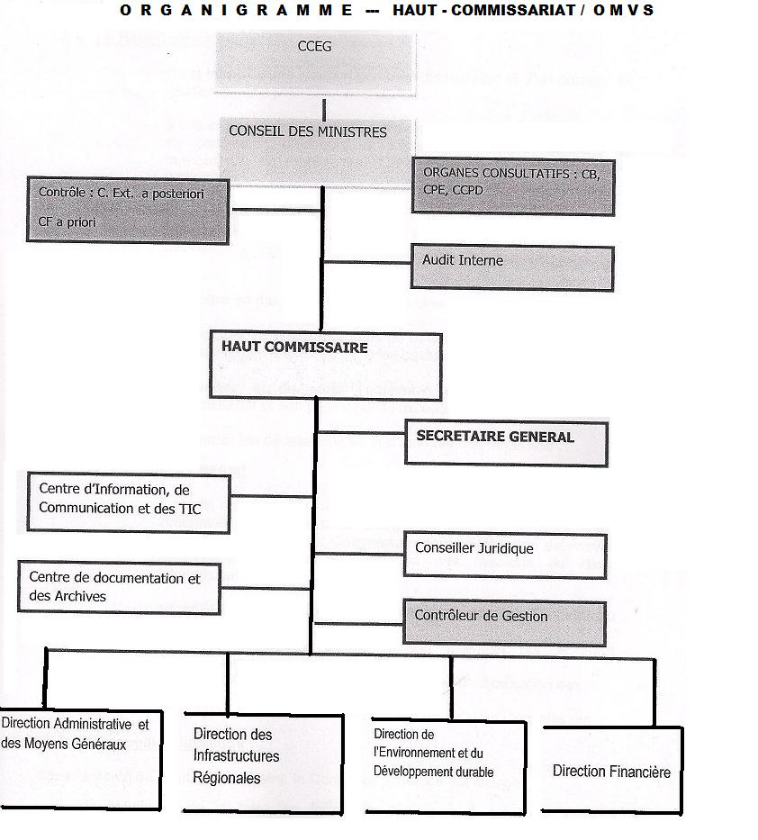

Table 5: Structure and operations of TBOs (OMVS and OMVG)

 | OMVS | OMVG
Agreement | Convention Establishing the Organization for the Development of the Senegal River (11 March 1972) | Convention Establishing the Organization for the Development of the Gambia River (1978)
Member States | Guinea, Mali, Mauritania, Senegal | Gambia, Guinea, Guinea Bissau, Senegal
Objectives | - Promotes and coordinates studies and operations to develop the resources of the Senegal River basin within the territories of member States  - Any technical and economic mission with which the States wish to jointly entrust it | - Promotes and coordinates studies and operations to develop the resources of the Gambia River basin within the territories of member States  - Any technical and economic mission with which the States wish to jointly entrust it
Political bodies | Conference of Heads of State and Government (CCEG):  - Defines cooperation and development policy  - Decisions apply to all member States, which commit to implementing them  Council of Ministers:  - Drafts general policies for developing the Senegal River, implementing its resources and cooperation between States  - Defines priority river development and river resource development activities  - Establishes States’ contributions  - Approves programmes affecting more than one State  - Decisions are binding for member States | Conference of Heads of State and Government (CGEG):  - Defines cooperation and development policy  - Decisions apply to all member States, which commit to implementing them  Council of Ministers:  - Drafts general policies for developing the Gambia River, implementing its resources and cooperation between States  - Defines priority river and river resource development activities  - Approves programmes affecting more than one State  - Establishes States’ contributions
Executive body | High Commission (led by a High Commissioner):  - Executive body  - Responsible for gathering basic data on the basin  - Submits the joint operations and rational river use programme to the Council of Ministers with the opinion of the Water Commission  - Studies hydro-agriculture development projects and submits them to the Council  - May be responsible for seeking financing  The Commission’s organizational structure is established by the Council of Ministers based on the High Commissioner’s suggestion. | High Commission (led by a High Commissioner):  - Executive body  - Responsible for gathering basic data on the basin  - Submits the joint working and rational river use programme to the Council of Ministers with the opinion of the Water Commission  - Studies hydro-agriculture development projects and submits them to the Council  - May be responsible for seeking financing  The High Commissioner is assisted by directors.
Advisory role | Permanent Water Commission:  - Responsible for defining the principles and methods for the distribution of water from the Senegal River between the States and among water use sectors: industry, agriculture, transport  - Comprised of State representatives  - Issues an advisory opinion to the Council of Ministers. | Permanent Water Commission:  - Responsible for defining the principles and methods for the distribution of water from the Gambia River between the States and among water use sectors: industry, agriculture, transport.  - Comprised of State representatives  - Issues an advisory opinion to the Council of Ministers.
Conflict resolution | - Recourse to conciliation or mediation  - If an agreement cannot be reached, resort to the OAU Commission of Mediation, Conciliation and Arbitration  - Last resort: ICJ | - Recourse to conciliation or mediation  - If an agreement cannot be reached, resort to the OAU Commission of Mediation, Conciliation and Arbitration  - Last resort: ICJ

Principles of water management
The Charter of Waters of the Senegal River establishes principles to be applied and considered when using the river. The Gambia River draft Water Charter strongly resembles the Charter of Waters of the Senegal River.
The Charter of Waters of the Senegal River gives limited aquifers and groundwater tables limited consideration, mainly with the objective of protection and knowledge development. The Gambia River draft Charter specifically notes that groundwater falls within its scope of application; in other words, the Charter applies to groundwater. However, the only other mention of groundwater in the Charter is with regard to data.
The Charter of Waters of the Senegal River refers to principles of international water law, such as reasonable and equitable use, and lists factors to consider for resource distribution. The Charter integrates environmental and ecosystem protection. It places particular importance on supplying water to populations, which should receive priority in cases of shortages. The text includes provisions regarding monitoring extraction through reporting or authorization. Finally, the Charter raises the importance of national legislation, as this is how environmental protection should be ensured. The Charter even specifies that it applies on a suppletive basis to anything not laid out by national legislation.
The Gambia River (including the Kayanga/Géba and Koliba/Corubal Rivers) draft Charter is generally based on the same principles. It advocates harmonizing national legislation with regard to water and the environment, in order to effectively fight all forms of pollution. The main provisions of both Charters are summarized in the table below (Table 6).
It is also worth mentioning that Guinea Bissau is party to the Convention on the Law of Non-Navigational Uses of International Watercourses (1997), and Senegal is party to the Convention on the Protection and Use of Transboundary Watercourses and International Lakes (1992). Additionally, the other SMAB riparian States have expressed an interest in adhering to one or both UN Global conventions on water.
Both of these Conventions are international instruments regarding transboundary water, to which it is possible to add draft articles regarding transboundary aquifers, which are the subject of five resolutions of the UN General Assembly (2008, 2011, 2013, 2016 and 2019) and annexed to two of them (2008 and 2013).
While both Conventions are binding for the States that ratified them, that is not the case of draft articles, which remain guidelines. However, the Conventions, and to a certain degree, the draft articles include principles that are part of international customary law, and therefore apply to all States.
The 1997 New York Convention has limited application to shared groundwater, as its scope only includes those connected hydrological to a system of surface waters. In fact, these conditions are rarely met together, or the state of knowledge on groundwater does not make it possible to know with any certainty.
The 1992 Helsinki Water Convention covers all transboundary water, without distinction. Therefore, all shared aquifers fall under its scope. Additionally, the “Model Provisions on Transboundary Groundwater” were adopted by the Parties to the Convention in 2012, with the aim of providing concrete directives to apply the 1992 Convention to groundwater. These provisions are based on the Draft Articles on the law of transboundary aquifers.
Finally, the draft articles include all transboundary aquifers in their scope of application. In addition to use of these aquifers and measures for their protection, preservation and management, the Draft Articles also cover “other activities with an impact on these aquifers… or which are likely to have one”, considering the demands of territorial management and activities likely to pollute, when an aquifer is present and its potential vulnerability.
Table 7 gathers the important principles of these international legal instruments, comparing them to the content of both Charters and provisions specific to national legislation.

Table 6: Senegal and Gambia River Water Charters
(draft law in blue, groundwater in bold, national legislation in italics)
 | Water Management Principles Charter of Waters of the Senegal River (2002) | OMVG Draft Water Charter
Objectives | - set principles and methods for distributing the waters of the Senegal River among different use sectors,  - define methods for examining and approving new water use projects or projects impacting water quality,  - determine rules regarding environmental preservation and protection,  - define the framework and methods for waters users’ participation in decision-making and managing Senegal River water resources.  (Article 2) | Define the general cooperation framework based on solidarity and reciprocity among member States to ensure the coordinated and sustainable management of shared basin water resources:  - promote subregional economic integration and cooperation among member States, notably by harmonizing and monitoring national policies, conservation and protection of shared basins,  - set principles and methods for the distribution and rational and equitable use of the three basins’ water resources, among various use sectors,  - promote and facilitate dialogue and cooperation among member States in designing and carrying out programmes, projects and any other development activity with an impact or likely to have an impact on the basins’ water resources,  - establish rules and principles regarding protecting the environment and biodiversity and preserving ecosystems, notably in sensitive zones,  - protect public health by monitoring disease vectors,  - promote scientific research and technological development, information exchange, capacity-building notably in IWRM and using appropriate technologies to sustainably manage basin resources.  (Article 2)
Scope of application | All Senegal River basin hydrography. (Article 3) | All activities dedicated to knowledge, governance, preservation, protection, mobilization and use of the Gambia, Kayanga/Géba and Koliba/Corubal River basins hydrography, as well as shared lakes and groundwater tables located in the basins in which partial or total renewal is linked to the Rivers’ hydrography.  The three rivers are declared to be international watercourses. (Article 3)
General principles of water distribution | - the obligation to guarantee balanced water resources management;  - equitable and reasonable use of the River’s waters,  - the obligation to preserve the environment,  - the obligation to negotiate in cases of conflict,  - the obligation for each riparian State to inform other riparian States before undertaking any activity or project that might have an impact on water availability and/or the possibility of implementing future projects.  These principles aim at ensuring populations are able to make full use of the resource and exercise their fundamental human right to clean water. (Article 4)  Distribution should take subregional cooperation and integrated resource management into consideration. (Article 5)  Water distribution considers the following essential components:  - storage capacity,  - sharing information on the River’s water lows for the consideration of acceptable use;  - operation security;  - water supply (urban and rural);  - environmental preservation and protection;  - support for agriculture (recessional, irrigated), livestock and continental fishing,  - hydroelectric production,  - freedom of navigation,  - reallocation of tax revenue resulting from taxing users responsible for pollution to financing ecological resource management,  - consideration of each user’s financial contribution to financing investments, recurring charges and debt repayment.  (Article 7)  Water resource use aims to fairly satisfy:  - populations’ drinking water needs, notably those of the most vulnerable;  - agriculture, livestock, forestry, fish farming, fisheries, flora, fauna and environmental needs,  - energy production water needs,  - industrial water needs,  - navigation water needs.  .  (Article 8) | Equitable distribution among the following uses:  - domestic, notably for drinking water,  - agriculture, livestock, forestry and fishing (including fish farming),  - industrial and for all energy production,  - tourism and leisure,  - navigation,  - needs for biodiversity and ecosystem preservation.  (Article 5)  Equitable and reasonable use in line with the principles of sustainable development and integrated management. The following is considered under this framework:  - pertinent geographical, hydrological, hydrogeological and climate data in each member State and in each of the three basins and aquifers linked to those basins,  - using available resources without waste, harming future generations or threatening ecosystems and the environment,  - not causing damage to other States,  - integrated development approach,  - Principle of preventive action,  - Polluter and User Pays Principle  - IWRM Principle  (article 6)  Water resources planning, conservation, management and development policies including:  - management of the hydrographic basin, and not only within administrative boundaries,  - responsible and transparent management with regard to riparian countries and users,  - equitable water sharing so as to avoid any conflict among users or member States,  - balanced management and rational use of the basins’ various water resources,  - balance between resource availability and each sector’s demand and economic and social weight,  - the obligation to preserve the environment, prevent pollution and end any waste of resources,  - the obligation to cooperate and negotiate in cases of conflict.  (Article 7)  Each member State commits to:  - mobilizing necessary water management competences,  - implementing an integrated resource management training system,  - contributing to the emergence of high-level scientific and technical research applied to water and river ecosystems,  - contributing to the implementation of a water information system,  - contributing to the smooth operations of cooperation platforms.  (Article 12)
Main priorities | Principle of non-discrimination,  Obligation to satisfy populations' vital and security needs.  (Article 6) | Each individual has a universal right to access to sufficient and sufficiently high-quality water to meet his or her essential needs, as well as the right to protection,  The principle of solidarity and non-discrimination,  The obligation to satisfy all users’ needs in the basin, independently of administrative boundaries.  (Article 4)
Usage priority | The Organization sets its priorities among water needs.  In the case of resource shortages, particular attention shall be granted to supplying drinking water and domestic water use.  (Article 9) | No user and/or riparian State shall have an absolute priority over others.  However, particular attention shall be granted to ensuring the needs of populations and livestock to guarantee their mobilization (drinking water and domestic use).  (Article 8)
Monitoring extraction and use | Domestic use is free.  Operations subject to authorization include:  - building or operating facilities or works,  - carrying out works or various activities (extraction, discharge or effluent) likely to present a danger to public health or safety, to damage the free flow of water, to reduce water resources, to impact the riverbed or harm the quality or biodiversity of the aquatic environment.  Authorization is granted by the Council of Ministers based on the opinion of the Permanent Water Commission.  Other operations are subject to simple reporting procedures, to be sent by each State to the High Commission.  A list of authorization and reporting thresholds will be drafted and implemented. With regard to quantity, operations’ authorization or reporting thresholds are based on the removal flow compared to the low flow. With regard to quality, thresholds consider the fragility of extraction or effluent. (Article 10) | Projects and works with a negative impact on basin resources require prior approval by member States, via the Permanent Water Commission (PWC).  Member States are subject to a reciprocal information and consultation requirement with regard to potential impacts from this type of project and the means to deploy in order to ensure proper management and equipment safety and maintenance.  (Article 15)
Environmental protection | Contracting States protect and preserve the River’s ecosystems, and manage resources while respecting natural balances, notably in fragile wetlands and marine environments, via national legislations and the OMVS.  (Article 16)  States shall jointly adopt a general environmental plan of action.  (Article 17) | Each member State is required to protect basin resources within its territory.  Member States must work in concert to harmonize their national legislations with regard to water and the environment to effectively fight against all types of pollution.  (Article 17)
Groundwater | Mapping of aquifer recharge zones:  - zone inventory,  - outline supply and catchment zones,  - understand interactions between surface water and groundwater.  (Article 17) | Shared groundwater tables fall within the scope of application.  (Article 3)  Aquifers linked to the basin are taken into account when considering data.  (Article 6)
Charter application | The provisions of the Charter apply on a suppletive basis to anything not laid out by national legislations.  (Article 12)
Conflict resolution | - Resolved by conciliation and mediation,  - If no agreement is reached- resort to the African Union Commission for Conciliation, Mediation and Arbitration,  - Last resort: International Court of Justice  (Article 30 | - Direct negotiation within the framework of the OMVG via the CPE.  - If no agreement is reached, the ECOWAS Court of Justice. The court’s decision may not be appealed.  (Article 23)

Table 7: Summary of international instruments and comparison with Water Charters and national legislations

 | Helsinki Water Convention (1992) /Model Provisions | New York Convention (1997) | Draft Articles 2008 | Charter of Waters on the Senegal River (2002)/Gambia River draft Water Charter | States’ national legislations
Reasonable and equitable use | Article 2§2c/Provisions 1 and 2:  Sustainable use  Protection of quantity and quality | Articles 5 & 6 (factors):  Optimal and sustainable use  Right to the use of watercourses  Duty to cooperate for their protection | Articles 4 & 5 (factors)  Right to equitably (#equal) use the transboundary aquifer  Optimal use → management plan, sustainable development, obligation to protect, including quality control | Articles 4 & 7 (factors)  Article 10: extraction reporting and authorization systems  Article 5: equitable distribution among uses  Article 6: equitable and reasonable use with respect for the principles indicated | Reporting and authorization systems
Obligation to not cause significant damage | Article 2§1/Provision 1:  Take appropriate measures to prevent, control and reduce any transboundary impact stemming from the use of transboundary groundwater or any activity that may impact it. | Article 7:  Not cause significant damage while using watercourses. | Article 6:  Not cause significant damage by using the aquifer or other activities other than aquifer use which have or may have an impact on that transboundary aquifer. | Article 6 | Reporting and authorization systems  Qualitative protection measures (monitor effluents, buffer zones, impact studies)
Data exchange | Article 6: Provide the broadest exchange of information as soon as possible  Provision 6: Carry out arrangements for the exchange of available information and data. | Article 9:  Regular exchange of available data.  Data is easy to communicate. | Article 8:  Regular exchange of available data.  Efforts to produce more complete data.  Data is easy to communicate.
Monitoring | Article 4/Provision 3:  Implement shared transboundary groundwater quantity and quality monitoring and evaluation programmes. |  | Article 13: Joint monitoring, otherwise data exchange.
Ecosystem protection | Article 2§2d/Provision 2:  Preserve transboundary groundwater tributary ecosystems. | Article 20:  Separate or joint ecosystem protection. | Article 10:  All measures to protect ecosystems dependent on aquifers (water quantity and quality). | Article 16: protection through national legislation. | Monitor extraction (quantity) (reporting and authorization).  Qualitative protection measures (effluent monitoring, buffer zones, impact studies).

Preventing, reducing and controlling pollution | Article 3§1/Provision 5:  Adopt all appropriate administrative, legal, economic, financial and technical measures. | Article 21:  Separate or joint action by States  Shared objectives and criteria  List of prohibited substances. | Article 12:  Separate or joint action by States. | Article 4: Obligation to preserve the environment  Article 17: Harmonize national water and environmental legislations to fight all forms of pollution. | Qualitative protection measures (effluents, buffer zones, impact studies).
Precautionary principle | Article 2§5a/Provision 5:  Apply the precautionary principle given groundwater’s vulnerability to pollution, in particular when the nature and scope of transboundary groundwater is uncertain. |  | Article 12: Precautionary approach in cases of uncertainty as to the nature and scope of the aquifer and its vulnerability to pollution.
Polluter pays principle | Article 2§5b |  |  | Article 6 | Fees for effluents
Management | Article 2§2B: environmentally-friendly and rational water management  Provision 4:  Integrated groundwater and surface water management  Provision 7: shared or coordinated management plans. | Article 24:  Consultations between States  Potential creation of a mixed mechanism. | Article 14:  Management plan  Consultation between States  If applicable, a management mechanism | Article 6: IWRM
Emergency situation |  | Article 28:  Cooperation among States, and with international organizations. | Article 17:  States adopt necessary measures to respond to vital human needs  Cooperation among states and with international organizations. |  | Order of priority of use in case of draught, flooding, etc.

Conclusion
Studying SMAB countries’ legal and institutional water frameworks at the national and regional levels leads to the following conclusions:
- At the regional level: The four States have been invested in cooperating on transboundary rivers (the Gambia and Senegal Rivers) for several decades, within the framework of two TBOs. While neither TBO includes all four States at the same time, as noted earlier, both TBOs work in a very similar fashion. Their operations are also very similar. Therefore, the four States are familiar with the procedures and requirements of transboundary water cooperation. SMAB cooperation might benefit from or be part of this framework, which offers opportunities to adapt and expand its scope of application to groundwater (this has partially been done with the Gambia River draft Water Charter). Certainly, expansion would be necessary at the institutional level and the level of legal principles, though the foundation already exists.
- Therefore, creating a crosscutting commission between the two organizations might be envisioned, with the SMAB States as members. This commission might be created by an agreement between the OMVS and OMVG, which would lay out its operational methods, as well as principles directly related to the SMAB (data exchange, management, protection…)
- Nationally, the countries’ legislations are not all at the same level. In Gambia, the water sector finds itself in a legal void, and though reforms have been undertaken, they have not always succeeded. In other countries, water code provisions are not at the same level either, particularly when it comes to protecting water from pollution, which should be strengthened, particularly with regard to groundwater. Water code revisions are underway and may be an opportunity to include provisions specific to groundwater. Strengthening national legislations is indispensable to ensuring sustainable groundwater management and allowing the application of the Charter principles and TBO agreements, as well as the possibility of developing cooperation for the SMAB. In addition to legislation on water, and above all for that regarding groundwater, other laws will be considered and certainly strengthened. Therefore, it will be necessary to evaluate regulatory and institutional frameworks on territorial development. They must be improved and organized in an intersectoral manner. This also applies to other laws, such as those regarding the environment.
- In three of the countries (Guinea Bissau, Mauritania and Senegal), the Ministries responsible for water include a liaison unit or department between the national water management level and the regional/international level. This demonstrates the degree to which cooperation has permeated the national levels. These departments might be directly involved in cooperation at the SMAB level. The Ministries’ work is more or less developed according to the country, and often reflect national legislation. Amending and strengthening laws on water will certainly require new developments within central and decentralized administrations. With a view toward cooperation on groundwater, it will certainly be necessary for the Ministries responsible for water to coordinate and work in concert with other Ministries (environment, agriculture…) This might be achieved through an Interministerial Water Committee, which, if it already exists, should see its capacities strengthened in the area of groundwater.

Groundwater classified as Zones I or II Zone I: 1. basins where groundwater use is approaching resource limits; 2. basins supplying communities served by a public water distribution service; 3. basins where there is a risk of salt-water intrusion. Zone II: all other basins (Article 30 of the Water Code)

